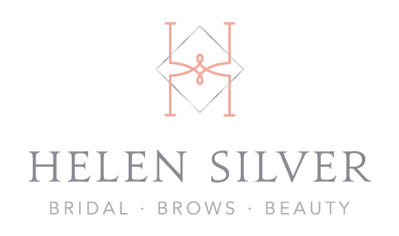
Coronavirus (COVID-19) Infection Prevention & Control Policy

For

Helen Silver Make-up & Beauty

All of us have been affected by the coronavirus (COVID-19) pandemic in different ways. My thoughts have been with all my clients. I have missed being able to offer you the treatments and I am looking forward to seeing you again as soon as possible.

My priority is to keep you as safe as possible, and prior to re-opening the salon I have implemented a number of changes which I would like to make you aware of. During the time the salon has been shut, I have completed the Coronavirus (COVID-19) Infection Prevention and Control course which is accredited by the Guild of Professional Beauty Therapists Ltd, the UK trade body for our industry. I have since made a number of changes in the way that we operate that you will notice when you next visit.

Booking Appointments

If I feel ill or have symptoms of C0VlD-19, I will self-isolate immediately and not come into the salon. This may mean that I have to cancel your appointment at short notice. I appreciate that this may be inconvenient but it is done entirely for your own safety. If your appointment is cancelled you will be able to re-book again as soon as I re-open.

If you or any of the people you live with feel ill or display any symptoms of C0VlD-19 – please advise us as soon as possible and DO NOT COME TO THE SALON FOR YOUR APPOINTMENT. We have amended our booking terms and conditions and you will not be charged for any appointments which you miss due to illness.

Visiting the Salon

For your safety and to maintain social distancing, I ask that you attend your appointments as close to the appointment time as possible. Please do not turn up early for appointments as this may mean that you come into contact with other clients who are just leaving. There is no communal waiting area so please come on time.

I have increased the frequency of cleaning in the salon including making sure that common surfaces, toilets door handles etc. are wiped clean using disinfectant products between each client.

All tools and equipment will be disinfected or sterilised in line with the specific manufacturers’ instructions for your safety.

Wherever possible we will utilise environmentally, friendly, single use items during a treatment that will be disposed of safely after use in order to protect you from cross infection.

You will have access to soap and hot water to wash your hands with as soon as you enter the salon and we will also have hand sanitiser available for you to use when you come into the salon.

I will understand and not be offended if you wish to wear a facemask when you visit the salon and during your treatment and can provide one too at a small cost.

I will also be wearing personal protective equipment (PPE) during your visit and during your treatment. This may include disposable gloves / facemasks / visor / aprons where appropriate.

I can confirm that the laundering of salon towels and uniforms is a priority I can assure you that all salon laundry is washed at 60 degrees C. Due to all towels and couch roll being used on the salon couch being one per customer, blankets are now not recommended. Please wear appropriate clothing to keep you warm, the temperature of air will be regulated with the heating accordingly.

All disposable items are bagged and safely removed from the treatment area between each client.

My treatments

I have carried out a risk assessment on all treatments and PPE/salon adjustments will be used to help significantly reduce the risk of any cross contamination.

During your treatment

Hand hygiene in accordance to NHS guidance will be followed before and during your appointment.

I will try to make your treatment as safe, comfortable and enjoyable as possible. If you have any concerns about your treatments please let me know.

After the treatment

In order to avoid handling of cash, l would prefer if you could pay for your treatment by card or bank transfer.

All of these procedures have been implemented for our safety. We will continue to take advice from the Government and the NHS regarding safe practice and will amend them as necessary.

Thank you for your understanding.

Helen Silver-Ross
Helen Silver Make-up & Beauty

